**1) The problem explaination:**

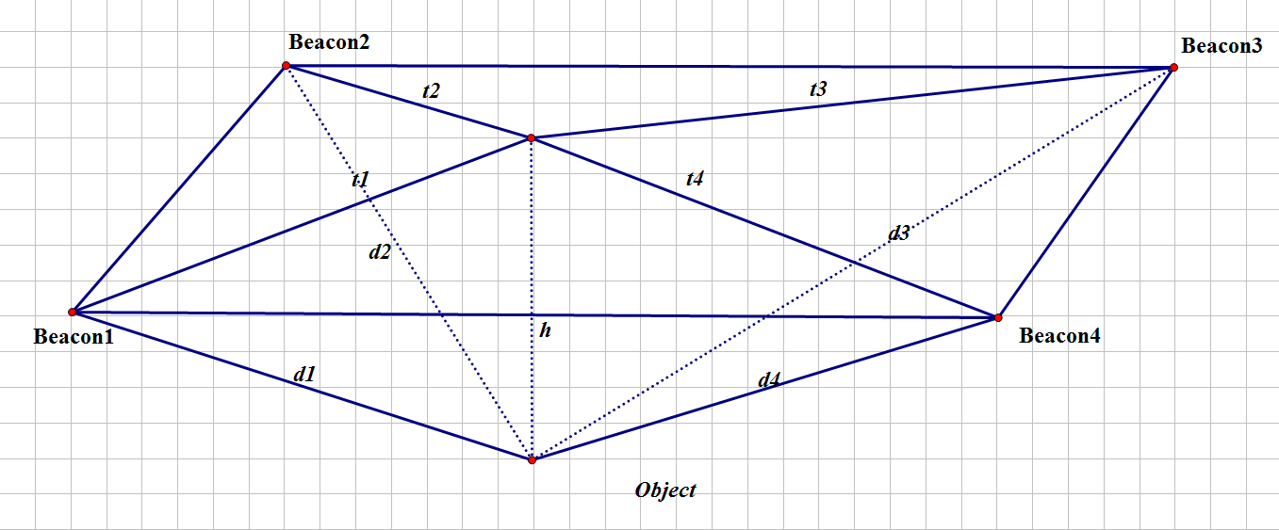

**Fig. 1**: Beacons and object position.

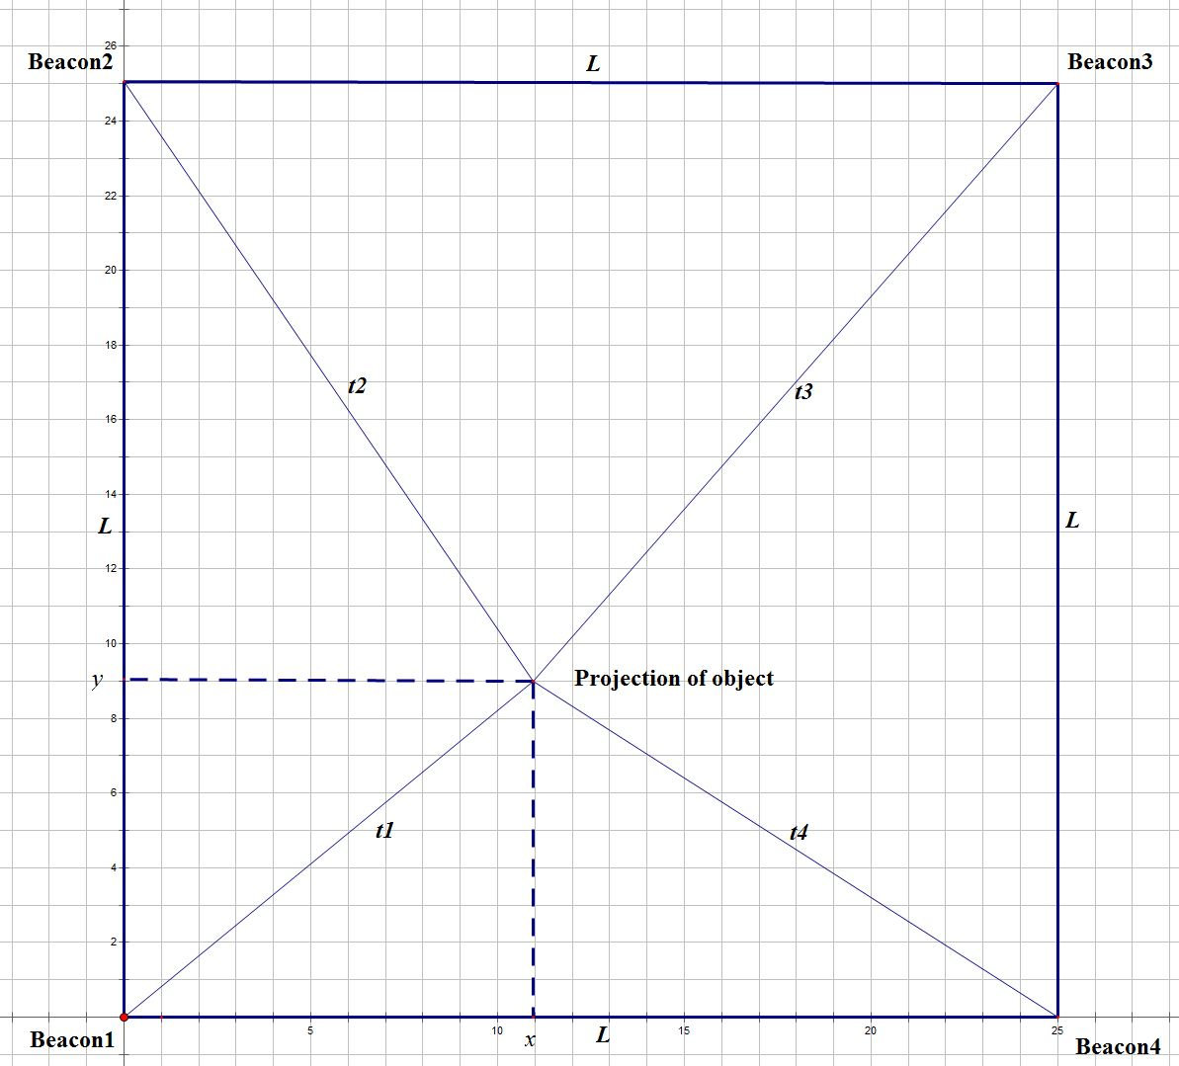

**Fig. 2**: Beacons and object projection.

**2) The methods:**

**Transimters(Tx)** are4 MIDASCON beacons which use Bluetooth Low Energy (BLE) technology. Each Beacon have their own MAC address and Tx power.

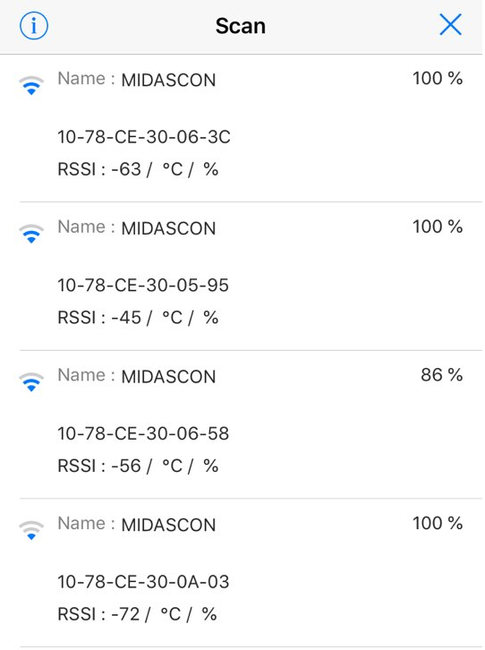

**Fig. 3**: MAC address and RSSI of Beacon when Rx is smartphone.

**-Receiver (Rx):** They will identify the received RSSI + MAC Address. The distance from Rx to Beacon is calculated based on following equation:

,

where *N* is path loss which indicate the enviroment factor, 

**Examples:** Assume we have:, *N* = 3 and , , and . We have the distance will be as follows:

, , and .

From 4 beacons, we get 4 radiuses: . We first calculate the radiuses. Then, the distance in plane as following:

.

We use **Triangulation** method for calculating position (x, y). From 4 Beacons, we can get 4 triangles as:

--For triangle (Projection of object, Beacon1, Beacon2):



--For triangle (Projection of object, Beacon2, Beacon3):



--For triangle (Projection of object, Beacon3, Beacon4):



--For triangle (Projection of object, Beacon4, Beacon1):



Then, the location of object is calculated by following equation:

.

**3) Experiment system:**

**Hardware:**

-Arduino UNO

-HM10 Bluetooth Module

-I2C-LCD (Liquid Crystal Display)

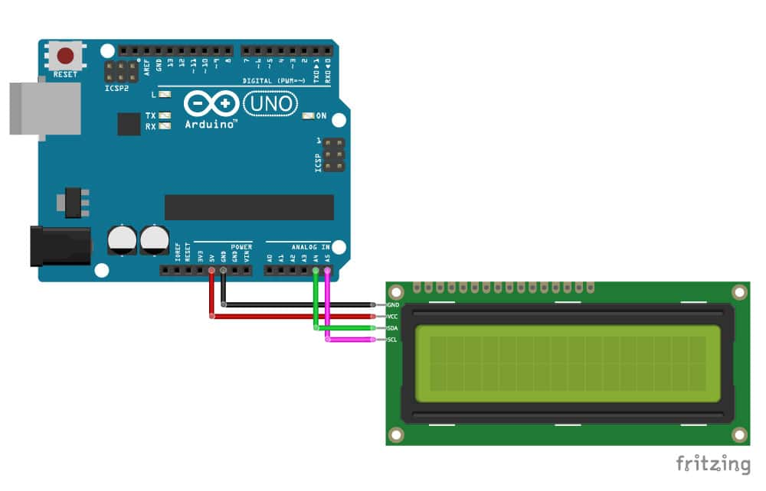

**Fig. 4**: Arduino UNO to I2C LCD diagram.

|  |  |
| --- | --- |
| I2C Character LCD | Arduino |
| GND | GND |
| VCC | 5 V |
| SDA | A4 |
| SDL | A5 |

**Tab. 1:** I2C-LCD and Arduino connection.

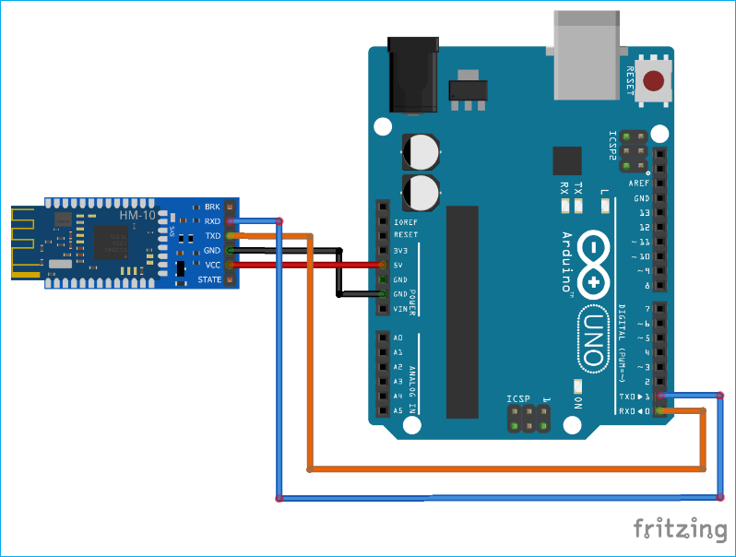

**Fig. 5**: HM-10 Bluetooth to Arduino UNO diagram.

|  |  |
| --- | --- |
| HM-10 | Arduino |
| GND | GND |
| VCC | 5 V |
| RXD | D2 |
| TXD | D3* |

**Tab. 2:** HM-10 Module and Arduino connection.

*: The pins on the actual HM-10 (the small daughter board) are 3.3v only. They are not officially 5v tolerant so use a voltage divider or something else to bring the voltage down to 3.3v. Then it pin to ~D3.

**References:**

1) <https://create.arduino.cc/>

2) <https://create.arduino.cc/getting-started/plugin>

3) <https://www.makerguides.com/character-i2c-lcd-arduino-tutorial/>

4) <https://circuitdigest.com/microcontroller-projects/how-to-use-arduino-and-hm-10-ble-module-to-control-led-with-android-app>

5) <http://arduino.vn/reference>